CURRICULUM VITAE

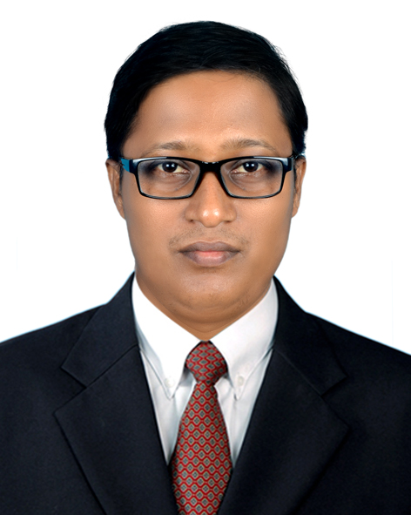

Of

Kishori Mohan Dey

**MAILING ADDRESS:**

**Bani Bhavan93rd Floor),Paul para,Chowdhuryhat,**

**Fatehabad,Hathazari,Chittagong.**

**Cell: 01811688642**

**Email: Kishori.bd@gmail.com**

**CAREER OBJECTIVE:**

“To build up my career in a renowned organization and gradually develop myself by working in a challenging position and contribution my knowledge, experience, enthusiasm and creativity for the advancement of the organization, as well as myself.”

**ACADEMIC BACKGROUND:**

**EMBA:**

Institution : University Of Chittagong,

Major : Marketing

Duration : 24 Month

Result : 2.85/4

Year of Passing : 2019

**Master of Arts (M.A):**

Institution : University Of Chittagong,

Major : Philosophy

Duration : 12 Months

Result : GPA -3.48/4

Year of Passing : 2010

\

**Bachelor of Arts (B.A):**

Institution : University Of Chittagong,

Major : Philosophy

Duration : 4 Years

Result : GPA- 3.49/4

Year of Passing : 2009

**Higher Secondary Certificate (HSC):**

Institution : Fatickchari Degree College

Group : Science

Result : GPA- 3.00/5

Year of Passing : 2005.

**Secondary School Certificate (SSC):**

Institution : Bhujpur Model High School

Group : Science

Result : GPA- 3.94/5

Year of Passing : 2003.

**WORK EXPERIENCE**

**Present Job:**

**Post:- Assistant Manager**

**Rangs Motors Ltd,**

**ChandpurBranch**

**from 10/11/2013 to 02/01/2020**

**Previous |Job:**

Post:-**Marketing Executive**

Gazi Tyres

Gazi Group

84-85, Water Works Road

Posta, Lalbagh

Dhaka-1211

Tel : 7319714-18

Fax : 02-7319713

(It is the largest and most renowned tyres manufacturer in

Bangladesh).

Since 01 August 2011 to 31-10-2013

**COMPUTER PROFICIENCY:**

**MS-Word, MS-Excel, Access, Power Point, Photoshop, Internet Browsing, E-mail,**

**Blogging, Graphics, etc.**

**LANGUAGE SKILLS:**

**Good command over Reading, Writing and Speaking in both English and Bengali.**

**PERSONAL DETAILS:**

Name : **Kishori Mohan Dey**

Father’s Name : Parimal Chandra Dey

Mother’s Name : Rekha Rani Dey

Date of Birth : 20-02-1988

Sex : Male

Marital Status : Single

Nationality : Bangladeshi (By Birth)

Religion : Hindu.

Permanent Address : Vill: West BhujpurP.O: Bhujpur, P.S Bhujpur, Dist: Chittagong.

Height : 5.10”

Blood Group : O+

Web : www.Bangladesh-kishorimohan.blogspot.com

E-mail : kishori.bd@gmail.com

Contact No : 01811688642

|  |
| --- |
| **Reference (s):** |
| |  |  |  |  |  | | --- | --- | --- | --- | --- | | **Particulars** |  | **Reference: 01** | **Reference: 02** | | | **Name** | : | **Rajesh Dutta** | **Dr. Tanvir Mohammed Hayder Arif** | | **Organization** | : | **Rangs Motors Limited** | **University Of Chittagong** | | | **Designation** | : | **AGM( Product Head)** | **Associate Professor** | | | **Address** | : | **117/A,Rangs Bhavon(Level-4),Bijoy Sarani,Tejgaon,Dhaka** | **Department Of Finance, University Of Chittagong.**  **Chittagong.** | | | **Email** | : | **Rajesh.datta@rangsgroup.com** | **Tanvir.arif@cu.ac.bd** | | | **Phone (Res.)** | : |  |  | | | **Mobile** | : | **01929919149** | **01715174403** | | |  |  |  |  | | | **Relation** | : | **Professional** | **Educational** | | |

---------------------------------------

**Kishori Mohan Dey**

DATE :----------------------